Advocacy support  - POhWER support centre can be contacted via 0300 456 2370  - Advocacy People gives advocacy support on 0330 440 9000  - Age UK on 0800 055 6112  - The Local Council can give advice on local advocacy services  - Other advocates and links can be found on this PHSO webpage  Further action  If you are dissatisfied with the outcome of your complaint from either Integrated Care Board (ICB) or this organisation, then you can escalate your complaint to Parliamentary Health Service Ombudsman (PHSO) at either:  Milbank Tower, Milbank  LONDON  SW1P 4QP  Citygate, Mosley Street  MANCHESTER  M2 3HQ  Tel: 0345 015 4033  www.ombudsman.org.uk | Sandy Lane Surgery & St Peter’s Medical Practice (Branch Surgery)  77 Sandy Lane, Mansfield, Notts NG18 2LT &  Chaucer House, Commercial Street, Mansfield, Notts NG18 1EE  01623 656055 & 01623 422355 – nnicb-nn.c84637@nhs.net |  | The Complaints Process  - Sandy Lane Surgery & St Peter’s Medical Practice (Branch Surgery)  
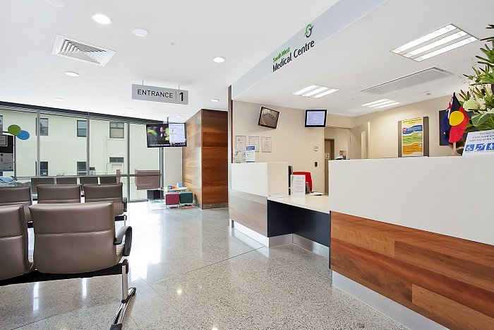  Talk to us  Every patient has the right to make a complaint about the treatment or care they have received at Sandy Lane Surgery & St Peter’s Medical Practice (Branch Surgery)  We understand that we may not always get everything right and, by telling us about the problem you have encountered, we will be able to improve our services and patient experience.  Who to talk to  Most complaints can be resolved at a local level. Please speak to a member of staff if you have a concern and they will assist you where possible. Alternatively, ask to speak to the Complaints Manager, Jill Towns – Practice Manager but note this may need to be a booked appointment. | If for any reason you do not want to speak to a member of our staff, then you can request that the Integrated Care Board (ICB) investigates your complaint. They will contact us on your behalf:  Patient Experience Team  Nottingham and Nottinghamshire Integrated Care Board  Civic Centre  Arnot Hill Park  Nottingham Road  Arnold  Nottingham  NG5 6LU  Tel: 0115 8839570  Email: nnicb-nn.patientexperience@nhs.net  A complaint can be made verbally or in writing. A complaints form is available from reception. Additionally, you can complain via email to  nnicb-nn.c84637@nhs.net  Time frames for complaints  The time constraint on bringing a complaint is 12 months from the occurrence giving rise to the complaint, or 12 months from the time you become aware of the matter about which you wish to complain.  The Practice Manager will respond to within three business days to acknowledge your complaint.  We will aim to investigate and provide you with the findings as soon as we can and will provide regular updates regarding the investigation of your complaint. |  | Investigating complaints  We will investigate all complaints effectively and in conjunction with extant legislation and guidance.  Confidentiality  We will ensure that all complaints are investigated with the utmost confidentiality and that any documents are held separately from the patient’s healthcare record.  Third party complaints  We allow third parties to make a complaint on behalf of a patient. The patient must provide consent for them to do so. A third-party patient complaint form is available from reception.  Final response  We will issue a final formal response to all complainants which will provide full details and the outcome of the complaint. We will liaise with you about the progress of any complaint.

